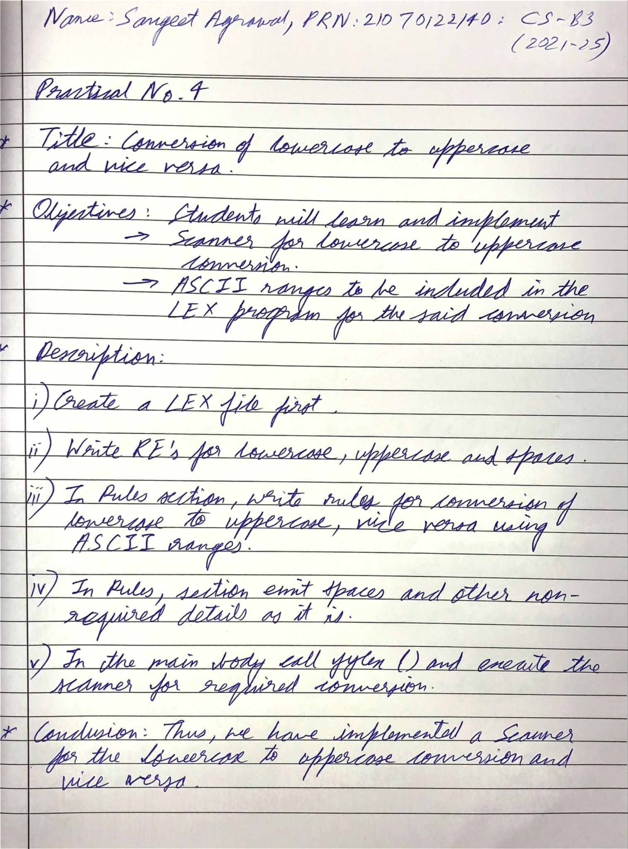

Code:

| %{ #include <stdio.h> #include <ctype.h> %}  alpha [a-zA-Z] digit [0-9] space [ \t\n]  %% {alpha} {  // Convert lowercase to uppercase and uppercase to lowercase  if (islower(yytext[0])) {  printf("%c", toupper(yytext[0]));  } else {  printf("%c", tolower(yytext[0]));  } }  {space} {  // Print spaces as they are  printf("%s", yytext); }  {digit} {  // Print digits as they are  printf("%s", yytext); } %%  int main(int argc, char **argv) {  if (argc > 1) {  FILE *file = fopen(argv[1], "r");  if (file) {  yyin = file;  yylex();  fclose(file);  } else {  perror("fopen");  return 1;  }  } else {  fprintf(stderr, "Usage: %s <filename>\n", argv[0]);  return 1;  }  return 0; }  int yywrap() {  return 1; } |
| --- |

Output:

